**Blinking LED Using Arduino and Serial Monitor**

**A Project Report**

**Submitted in Partial Fulfillment**

**Of the Degree of**

**Bachelors of Computer Applications**

**Supervisor’s Name –** **Submitted By- :**

**Mr. Pawan Kumar** **Simran Roy**

**Ms. Rachna Minocha Roll. No – 120920061**

**Semester-Ⅲ**



**JaganNath University**

**Bahadurgarh (NCR)**

**(2020-23)**

**PROJECT CERTIFICATE**

This is to certify that the project report entitled **Blinking LED Using Arduino and Serial Monitor** submitted to **JaganNath University, Bahadurgarh** in partial fulfilment of the requirement for the award of the degree of **BACHELOR OF COMPUTER APPLICATIONS (BCA)**, is an original work carried out by **Ms. Simran Roy** Enrollment No.: 120920061 under the guidance of **Mr. Pawan Kumar** .

The matter embodied in this project is a genuine work done by the student and has not been submitted whether to this University or to any other University/Institute for the fulfilment of the requirement of any course of study.

Name of student: Name of the Guide:

**Simran Roy Mr. Pawan Kumar**

**Ms. Rachna Minocha**

Signature of the Student

Signature of the Guide

Enrolment No. : 120920061 Date:

**ACKNOWLEDGEMENT**

I would like to express my special thanks of gratitude to my **IoT professor** **Mr.** **Pawan Kumar** and my **Supervisor Ms. Rachna Minocha, Assistant Professor,** who gave me this golden opportunity to do this wonderful project on the topic **Blinking LED with Serial Monitor**, which also helped me in doing a lot of Research and I came to know about so many new things. I am really thankful to them.

Secondly, I would also like to thank my team member **Ms. Shreya Garg** who constantly helped me with this project and by whose support I accomplished it and lastly, my parents and friends who helped me a lot in finalizing this project within the limited time frame.

**INDEX**

|  |  |  |
| --- | --- | --- |
| **Sl No.** | **Name** | **Page No.** |
| 1 | Introduction | 1 |
| 2 | Objectives | 2 |
| 3 | Tools/Environment | 3 |
| 4 | Circuit Diagram | 4 |
| 5 | Program Code | 5-6 |
| 6 | Input and Output Screens | 7-10 |
| 7 | Limitations of the project | 11 |
| 8 | Future Application of the project | 12 |
| 9 | Bibliography |  |

**INTRODUCTION**

The title of the project is Blinking LED using Arduino and Serial Monitor. In this project, by the help of coding and hardware elements particular LEDs are made to blink by taking inputs from the user through serial monitor. As the user enters the first letter corresponding to the colour of the LED, it glows simultaneously.

LEDs are small, powerful lights that are used in many different applications. The open-source Arduino Software (IDE) makes it easy to write code and upload it to the board. This software can be used with any Arduino board. Arduino boards are able to read inputs - light on a sensor, a finger on a button and turn it into an output - activating a motor, turning on an LED, publishing something online.

**OBJECTIVES**

* The main objective or goal of this project is to make the LEDs blink on the basis of the first letter of the corresponding colors of the LEDs.
* We have used three colors for LEDs, Red, Green and Blue. As soon as the first alphabet of the three desired colors of LED is entered by the user through the keyboard, it will glow.
* All the LEDs should glow when the letter ‘O’is entered.
* All LEDs should be turned off when the letter ‘X’ is entered.
* In order to attain all the objectives mentioned above each step in the code should be analyzed thoroughly and proper connections should be made to obtain the desired output in the hardware.

**TOOLS/ENVIRONMENT**

The following tools are required to make the setup ready for this project**:**

* **Softwares:**
* Arduino UNO(IDE)
* Operating System: Windows, Linus, Macintosh OSX
* **Hardwares:**
* Arduino UNO R3 board
* USB cable
* LED Breadboard
* Three LEDs
* Four Jumper wires( Male-Male)
* Three Resistors(330Ω each)

**CIRCUIT DIAGRAM**

**PROGRAM CODE**

1. const int redPin=10;
2. const int greenPin=9;
3. const int bluePin=8;
4. void setup() {
5. // put your setup code here, to run once:
6. pinMode(redPin,OUTPUT);
7. pinMode(greenPin,OUTPUT);
8. pinMode(bluePin,OUTPUT);
9. Serial.begin(9600);
10. Serial.println("type R-RED ON, G-GREEN ON, B-BLUE ON, O-ALL is ON, X-ALL is OFF");
11. Serial.print("Choose the letters");
12. }
13. void loop() {
14. // put your main code here, to run repeatedly:
15. if(Serial.available()>0)
16. {
17. char comdata=char(Serial.read());
18. if(comdata=='R')
19. {
20. Serial.println("Red LED is ON");
21. digitalWrite(redPin,HIGH);
22. }
23. else if(comdata=='G')
24. {
25. Serial.println("Green LED is ON");
26. digitalWrite(greenPin,HIGH);
27. }
28. else if(comdata=='B')
29. {
30. Serial.println("Blue LED is ON");
31. digitalWrite(bluePin,HIGH);
32. }
33. else if(comdata=='O')
34. {
35. Serial.println("ALL LED is turn ON");
36. digitalWrite(redPin,HIGH);
37. digitalWrite(greenPin,HIGH);
38. digitalWrite(bluePin,HIGH);
39. }
40. else if(comdata=='X')
41. {
42. Serial.println("ALL LED is turn OFF");
43. digitalWrite(redPin,LOW);
44. digitalWrite(greenPin,LOW);
45. digitalWrite(bluePin,LOW);
46. }
47. }
48. }

**INPUT AND OUTPUT SCREENS**

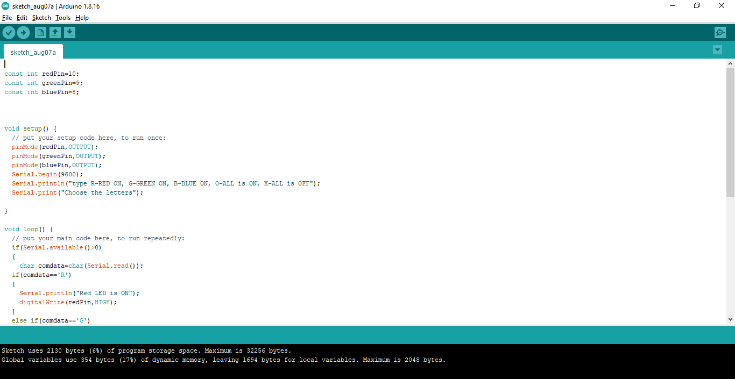

**Fig 6.1**

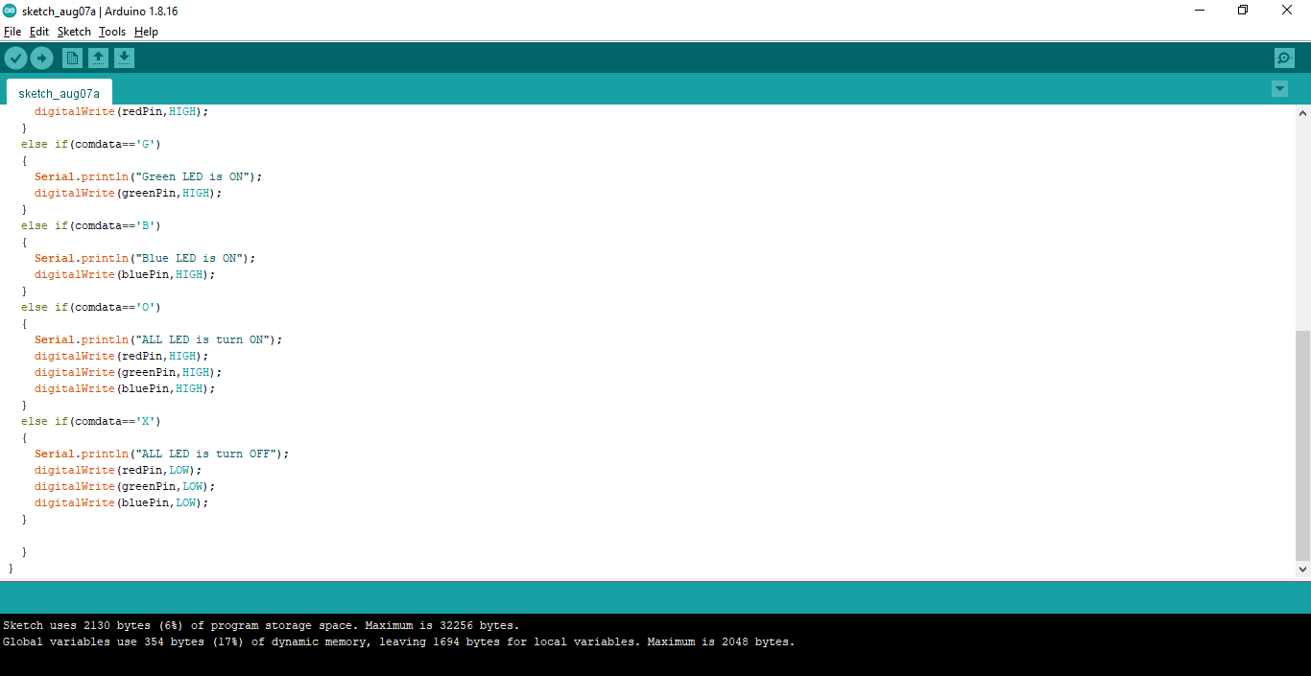

**Fig 6.2**

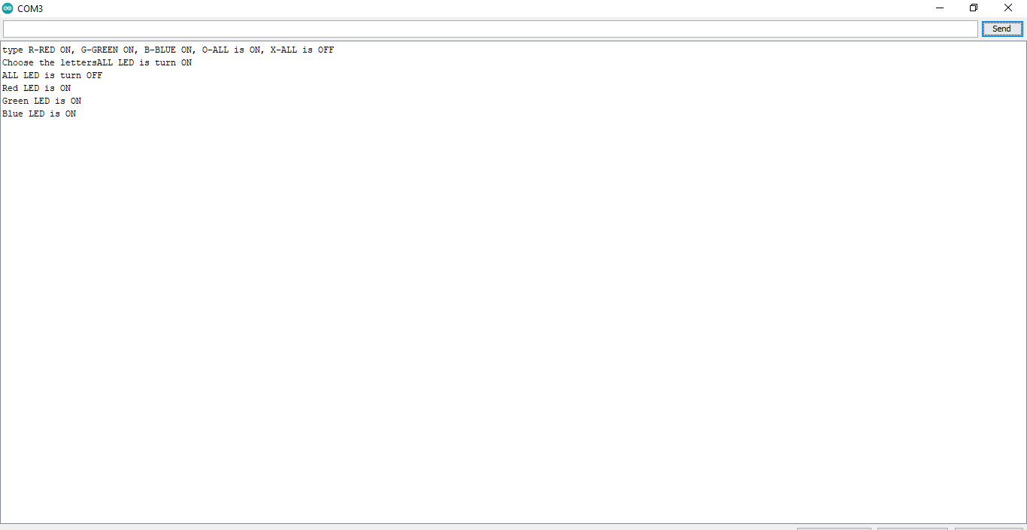

**Fig 6.3**

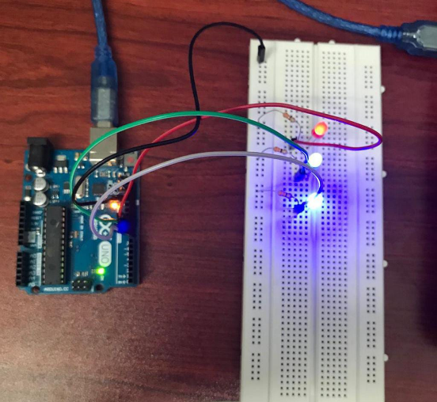

**Fig 6.4**

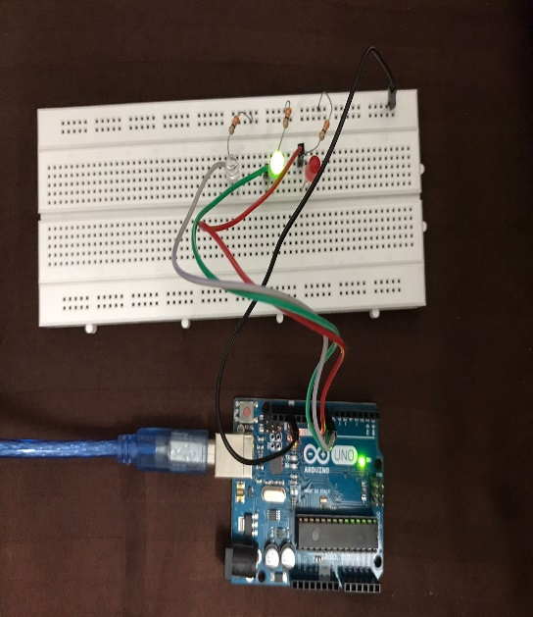

**Fig 6.5**

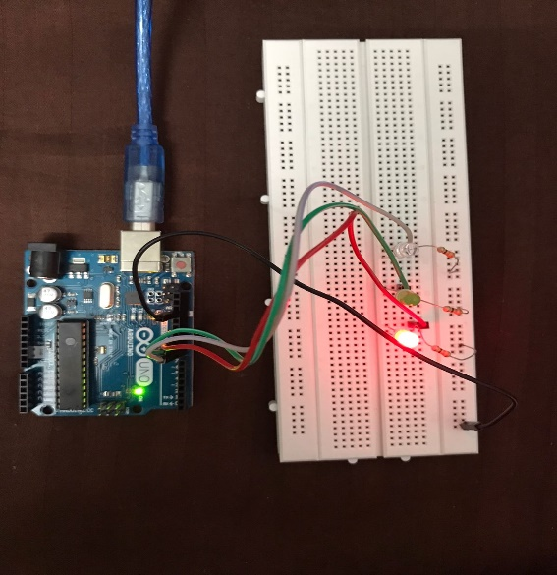

**Fig 6.6**

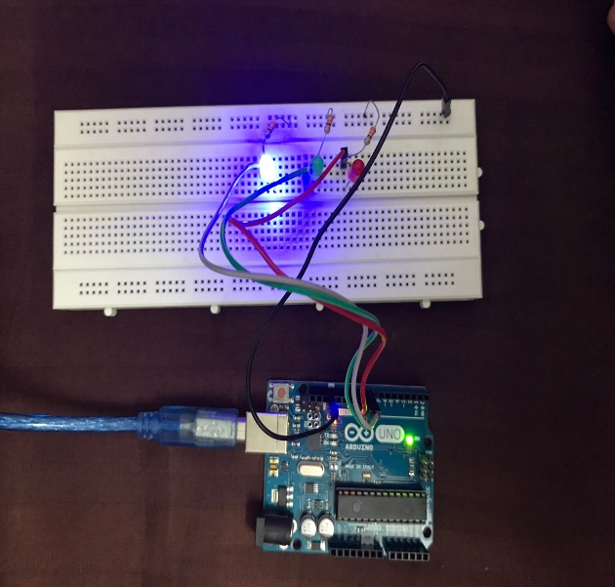

**Fig 6.7**

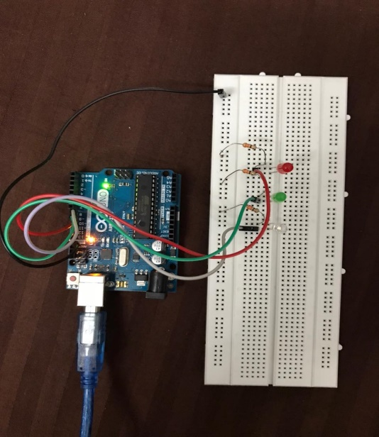

**Fig 6.8**

**LIMITATIONS OF THE PROJECT**

The following are the limitations of this project:

* The upload process sends data from computer to Arduino and Arduino sends status messages back to the computer to confirm the transfer is working, this may take time.
* It is limited to only 3 colors.
* Every time the correct baud rate is to be selected from the drop-down box on the bottom right of the Serial monitor.
* The hardware used is too delicate and any loose connections may interrupt in the working of this project.

**FUTURE APPLICATIONS OF THE PROJECT**

The following are the future applications of Blinking LEDs using Serial monitor:

* It can be expanded to more colors.
* It can be used to blink LEDs in a particular pattern according to the requirements.

**BIBLIOGRAPHY**

* Google-https://www.arduino.cc/en/Tutorial/BuiltInExamples/Blink
* YouTube-https://www.studentcompanion.co.za/bl